**NAME: NICKOLAS SHTAYN**

**LIBRARY MANAGEMENT SYSTEM**

Setting up database:

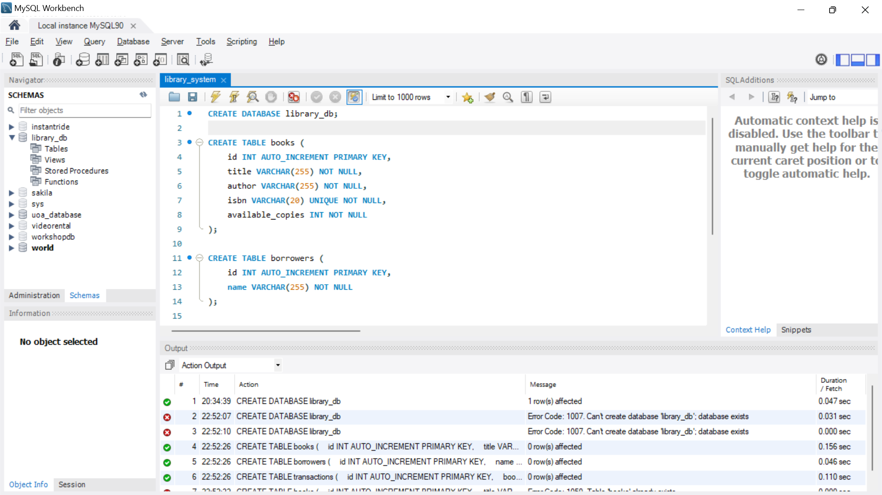

Backend set up:

